Chapter 19, Solution 44.

Using Fig. 19.99, design a problem to help other students to better understand how to find the transmission parameters of an ac circuit.

Although there are many ways to solve this problem, this is an example based on the same kind of problem asked in the third edition.

Problem

Determine the transmission parameters of the circuit in Fig.19.99.

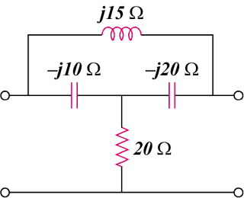

Figure 19.99

Solution

To determine  and , consider the circuit in Fig.(a).
j15 
20 
-j20 
+
−
(a)

I_{o}'
V₁
I₂ = 0
-j10 
+
V₂
−
I₁
I_{o}
I_{o}
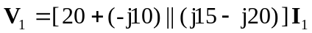
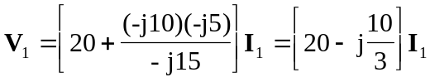

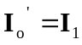

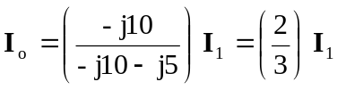

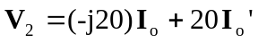 = 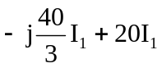 = 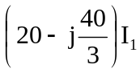

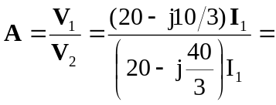 0.7692 + j0.3461

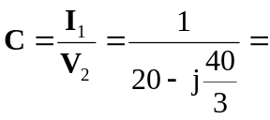 0.03461 + j0.023

To find  and , consider the circuit in Fig. (b).
j15 
20 
-j20 
+
−
(b)

V₁
-j10 
I₁
I₂
+
V₂ = 0
−

We may transform the  subnetwork to a T as shown in Fig. (c).

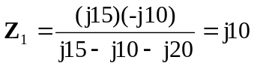
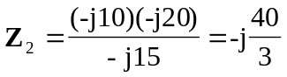
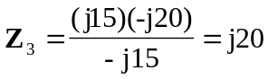
j10 
20 – j40/3 
+
−
(c)
I₁
I₂
+
V₂ = 0
−
V₁
j20 

